Airbus support to accident investigation
Nicolas Bardou
Mr Nicolas Bardou was appointed Director of Flight Safety - Accident/Incident Investigations in 2006 within the Airbus Product Safety team. In this function, he leads Airbus investigations of major events in support to the official investigation board activities. In his current position, Mr Bardou has developed expertise in the accident investigation domain by coordinating the Airbus team’s multiple on-site activities, FDR analyses and associated engineering studies, and operational reviews, thus addressing the safety issues and capturing the lessons learned. Prior to assuming this position, he served 6 years in the Flight Test Department for in-service and development aircraft flight test analysis.

Event synopsis
On Saturday, 31st of October 2015, at 0350UTC A321 registered EI-ETJ operating departed from Sharm El-Sheikh, Egypt under flight number 7K-9268 to St. Petersburg, Russia with two cockpit crew members, 5 cabin crew members and 217 passengers on board. At 0412UTC the Aircraft was vanished from Radar Monitor. Aircraft wreckage was found in central Sinai (about 131 nautical miles north of Sharm El Sheikh city).
The aircraft was completely destroyed and there were no survivors. The aircraft debris field was spread over more than 16km south east of the main wreckage area, typical of an in-flight break up in flight.

Airbus Crisis response
Airbus Toulouse Crisis Control Center was immediately activated and contact was made with Bureau d’Enquêtes et d’Analyses (BEA), airline representatives and with the Investigator In Charge (IIC) from Egyptian Central Directorate Of Aircraft Accident Investigation (ECAA) leading the investigation.

The IIC accredited representatives from all the countries involved:
- Russia (MAK) being state of the Operator
- France (BEA) being state of Design
- Germany (BFU) being state of Manufacture
- Ireland (AAIU) being state of Registration
- United States of America (NTSB) being state of Engine Manufacture

The operator was appointed Technical Advisor to the ECAA.
Pratt & Whitney was appointed Technical Advisor to the NTSB.
EASA and Airbus were appointed Technical Advisor to the BEA.

Airbus Chief Product Safety Officer decision to dispatch a go team is always made after information consolidation from multiple sources (local field representatives, embassy, media…), medical checks of each team members and security assessment as appropriate.

The Airbus Go Team arrived in Cairo November 1st. It was composed of an Airbus Product Safety accident investigator assisted by 2 corporate security officers and specialists from powerplant, aircraft systems and structure. This team was then reinforced by 4 additional members from Product Safety, Flight Test and flight recorders to support FDR analysis.

Mission preparation
First information shared by the IIC revealed that the accident site was isolated, spread over several kilometers and only accessible by helicopter (1h30, 280km) with daily rotations from dawn to dusk. This would limit the time available on site and would require several coordinated teams. Both recorders were already located and were being recovered so a separate team was set up to prepare data retrieval in Cairo facilities.
The Egyptian authorities shared security information and presented its objectives for the coming days. If weather permitted, investigators would be dispatched on accident site every day thanks to the means provided by Egyptian ministry of transportation.
Airbus security officers gathered a maximum of information in terms of accident site location, security dispatch set up at and around the wreckage, weather forecast and logistics for the journey (communication means, food, water, medical first aid kits). They continuously assessed the security situation by gathering and sharing information with all the parties involved. They were empowered to stop the Airbus mission at any time if required.
This allowed the team of investigators to only focus on technical mission.

Mission preparation & coordination
As the time on site was limited, the objective was to maximize efficiency by splitting the teams in groups:
- First group would detail the “main” wreckage (Figure 1 - Russian TV footage) formed by the forward fuselage up to the wings and both engines (separated from the wings).
- Second group would focus on rather large fuselage parts present few kilometers from the main wreckage site.
- Third group would try to reach most remote light aircraft parts.

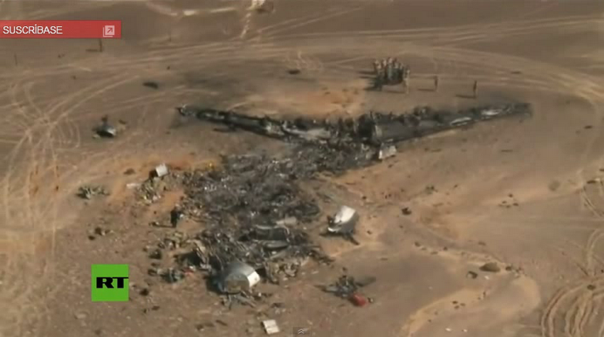
Figure 1 - Russian TV footage
Each group was composed of representatives from each organization. As there is no GSM coverage in that area, iridium phones and walky-talkies were used to ensure coordination and communication between those groups.
Before each group separated, an initial risk assessment and awareness was proposed by the Operator and Airbus and validated by the Investigator In Charge.

Initial Risk assessment
Indeed, the operator and the manufacturer can provide relevant information to the investigation boards concerning cargo potential dangerous goods, fuel estimation at time of impact, location and number of oxygen bottles, fire extinguishers, oil tanks, composite material, batteries… (Figure 2 – Airbus Aircraft Rescue and Firefighting Chart (ARFC)). All these elements are to be carefully taken into consideration before approaching a damaged aircraft.

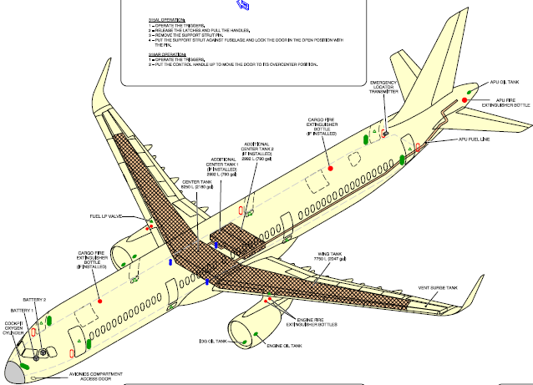
Figure 2 – Airbus Aircraft Rescue and Firefighting Chart (ARFC)
As the area to cover in the desert was immense with a limited time on site each group were requested to only gather factual of information while keeping analysis and identification for a later stage. Each group recorded wreckage evidences by taking GPS position and pictures of each part.
Upon return to the Egyptian Central Directorate Of Aircraft Accident Investigation headquarters all information collected was shared with all members of the investigation and the missions for the next days could be prepared.

Next missions
Viewing the accident site configuration -spread over several kilometers- it appeared that the initial event occurred at rather high altitude and that the first parts to detach would be the furthest ones from the main wreckage.

Airbus Defense & Space shared “Pleiades” very-high-resolution imagery to help the team locating wreckage parts and preparing the missions.

In the desert access can only be done by 4wheel-drive cars respecting topology and following “wadi” protected by Egyptian military forces (Ground and Air). Groups were then split according to areas that could be reached following pre-determined routes (Figure 3 – Areas determination on Google Earth), that would avoid the groups to search for route access, avoid long detours and save time.

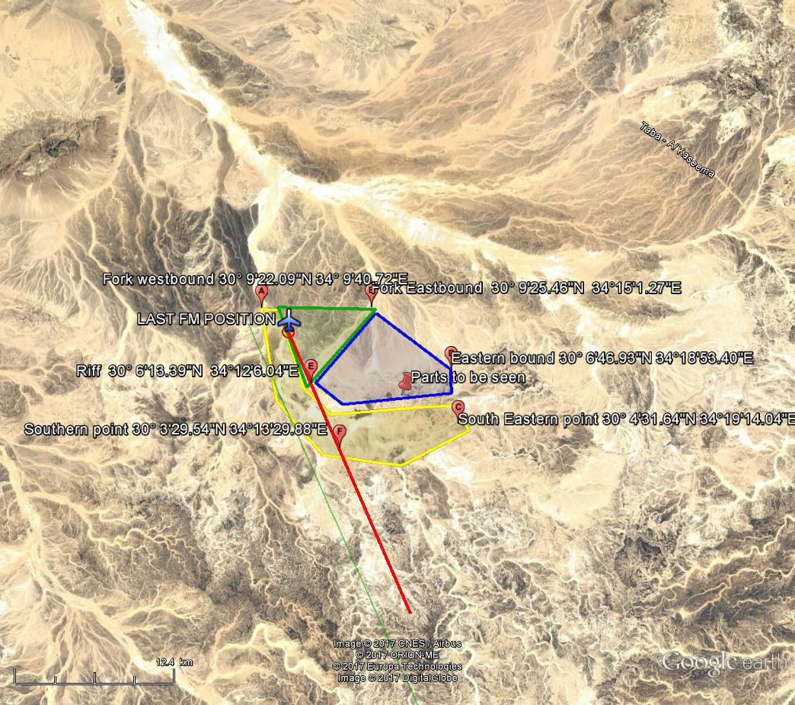
Figure 3 – Areas determination on Google Earth

Evidence collection, engineering analysis
Due to the very large number of wreckage parts and evidence collected, Airbus set up a “mirror” team coordinated from Toulouse Crisis Control Center composed of experts to analyze collected data that was transferred overnight from Cairo on a secured server. From the collected pictures and on-site observations, they performed precise identification of aircraft parts and in depth analysis of high lift and fuel systems, doors and exits, powerplant, airframe structure… then transmitted the results of their review to Cairo’s team.

On the systems side, this helped to rule out some scenarios and help the on-site team to focus on the remaining ones.

On the structure side, for each aircraft part, they could identify the part and locate it precisely on the aircraft. While performing the identification, they drew the contour of each part on a spreadsheet by counting its frames and stringers. This allowed having a global vision of what was recovered, what was still missing and which parts were adjacent to which other.

Aircraft 3D mock up
Aircraft 3D mock-up is a Catia based tool representative aircraft airframe and systems. This tool is usually used for design and production purposes. It is composed of several layers; the idea here was to derive this tool from its original purpose and use it for a 3D reconstruction of the wreckage. The 2D drawings were redrawn on the external layer (as is it were decals) and applied to the airframe layer to display each part precisely (Figure 4 – From wreckage picture to contour drawing and 3D modelling.).

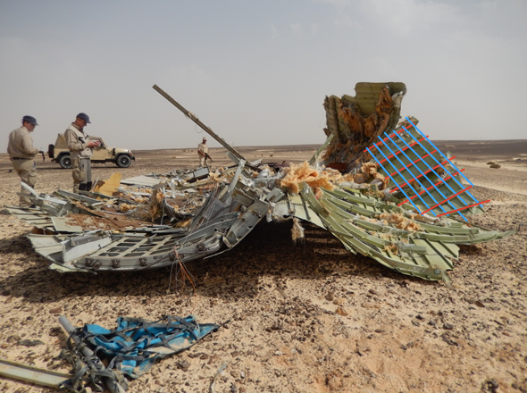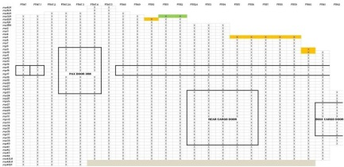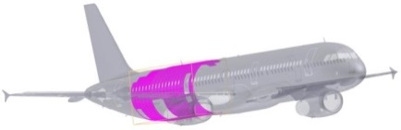
Figure 4 – From wreckage picture to contour drawing and 3D modelling.
Then one by one, each wreckage part was placed on the mock-up. Parts with common side matched very well, and it appeared that more than 95% of the aircraft could be reconstructed.

This 3D visualization allowed identifying areas of particular interest for the investigation where it was thought that the event initiated (Figure 5 - 3D mock up visualization of identified wreckage parts).
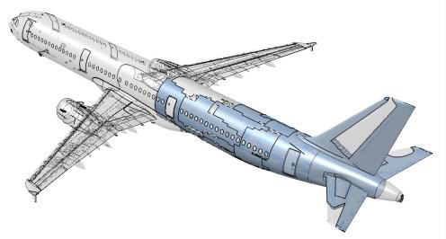
Figure 5 - 3D mock up visualization of identified wreckage parts

Wreckage layout
In order for the metallurgist and structure specialists to deeper investigate the parts located in those areas and to analyze the interfaces between them, the investigation team decided to gather all the wreckage parts from the desert and to perform a wreckage surface layout reconstruction (Figure 6 – Wreckage parts gathered from the Sinai desert).

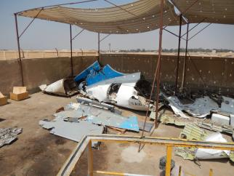
Figure 6 – Wreckage parts gathered from the Sinai desert
The Egyptian Central Directorate of Aircraft Accident Investigation managed to transport every part associated with the accident from the desert to an area close to Cairo airport using exceptional means and convoy.
Before starting this “giant jigsaw puzzle”, a work process was proposed by Airbus and agreed by all the parties. Basically, a fuselage can be represented as a cylinder composed of circular frames and longitudinal stringers. If this cylinder is split open from its top and rolled over this would end up in a 2D grid where frames and stringers references can be used as coordinates to locate precisely every part (Figure 7 - Fuselage split open representation).
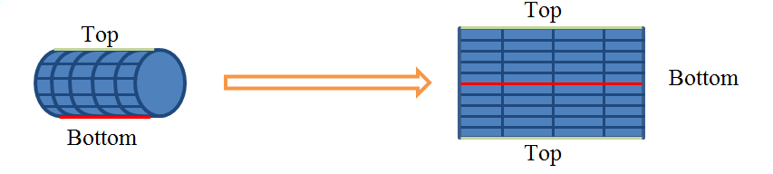
Figure 7 - Fuselage split open representation

Viewing the size and weight of certain parts and the limited space for the cranes and lift forks to maneuver, the order in which each part was put on the grid was of key importance. We used a white board to draw the grid and label each part (Figure 8 – Parts location using grid on white board) and to agree on the way forward before starting to move any heavy part.

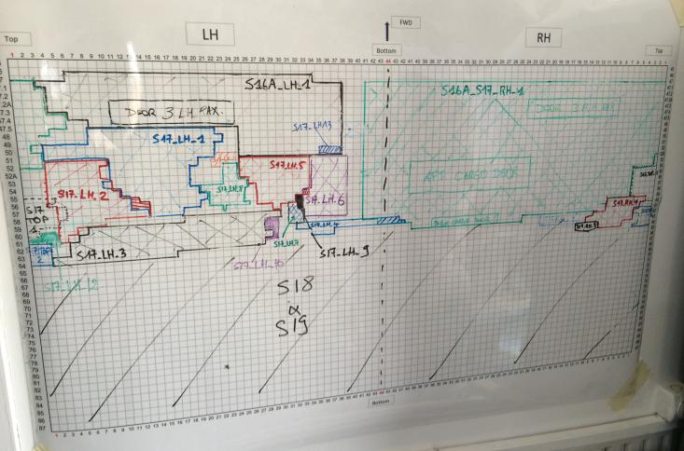
Figure 8 – Parts location using grid on white board
This grid was painted on the floor (Figure 9 – Grid painted on the floor) in order to reproduce what was planned on the white board.

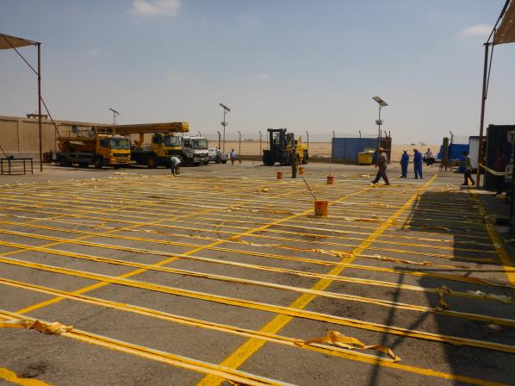
Figure 9 – Grid painted on the floor
When the whole plan was agreed with all the parties and presented to the drivers, we could start positioning each part at its correct location.

Thanks to the preparation work and advanced discussions with all the involved parties and the exceptional dexterity of the Egyptian drivers the wreckage surface layout could be completed in only a couple of days (Figure 10 – Wreckage surface layout in progress).

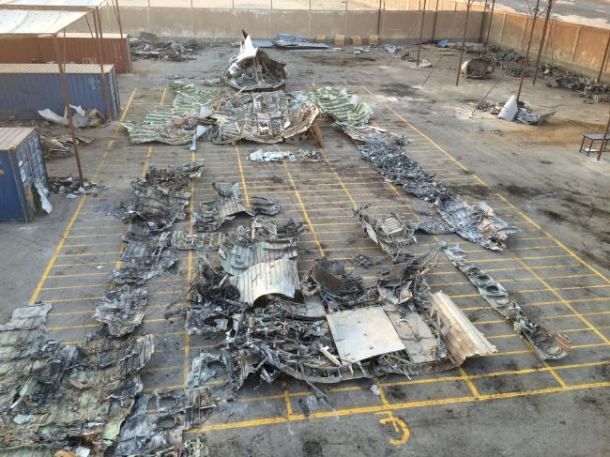

Figure 10 – Wreckage surface layout in progress
Once this was performed, the investigation team had a global view of the aircraft wreckage and focused on particular areas of interest. Metallurgists and structure specialists were not only able to examine fracture surfaces and lines propagation but also to confront those to adjacent ones. From this, they could identify parts to be sent to the laboratory for further investigations.

Conclusion

Airbus support to this particular accident investigation was continuously provided to the investigation boards throughout all the phases of the investigation.

By sharing its resources and expertise, Airbus provided on-site support for security and risk assessment by dispatching a team of experienced investigators and specialists but also provided its expertise and support in mission planning and wreckage identification using all available resources globally within the whole Airbus Company.

Airbus support to the investigation was not limited to on-site investigations but was backed up by teams of expert coordinated from Toulouse Crisis Control Center who worked in parallel to the field investigation in order to multiply efficiency and ensure proper reactivity.

Finally, Airbus proposed best adapted tools and resources that could support the investigation and created new ways of using them.

This allowed to perform a complete mapping and identification of a wreckage spread over 16km in the desert and to assist the investigation team to complete wreckage 3D reconstruction and physical layout less than 1 year after the accident.

Finally, metallurgists and structure specialists could determine in-flight break up point of initiation and send structure samples to laboratories for root cause analysis.

